Dual-Aperture Fiber Nulling for High Spatial and Spectral Resolution Studies of Exoplanets
80NSSC22K1197

Anusha Pai Asnodkar
The Ohio State University
(971) 331-9011
paiasnodkar.1@osu.edu

Accomplishments
We are demonstrating a “dual-aperture fiber nuller” (DAFN) as a technology to improve current standards of starlight suppression and angular resolution for high contrast imaging of Solar System giant planet analogs and habitable-zone planets. Our testbed is depicted for reference in Figure 1. During this reporting period, we have worked towards two of our milestones: 1) reproducing the vortex-fiber nuller (VFN) experiment and 2) wavefront sensing and correction. We will address our progress on these milestones as well as our current efforts in this section.

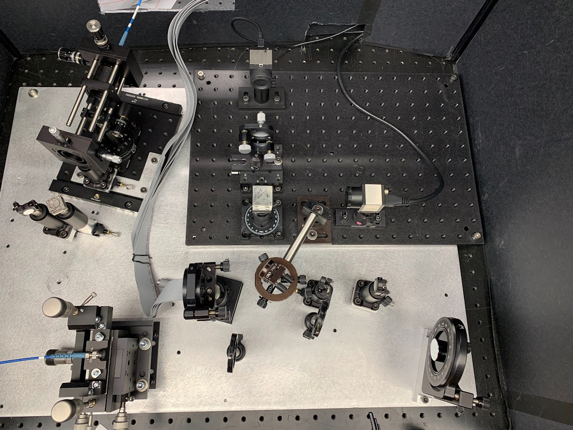Reproducing the VFN experiment in monochromatic light
LBTI simulator
Wavefront sensing
Laser source
Off-axis parabola
Deformable mirror
Beamsplitter
Fold
mirror
Beamsplitter
Shack-Hartmann sensor
CCD
Right-angle prism mirror
CCR
Vortex waveplate
Imaging
lens
Fiber-coupling optics
Fiber injection unit
SMF
Figure 1: DAFN testbed. Not pictured: corner cube reflector (CCR) for beam interference with adjustable path length.
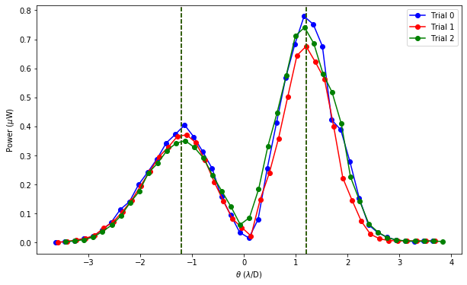
A vortex waveplate performs a spiral wavefront transformation in phase around a singularity to produce an on-axis null that can be harnessed for starlight suppression. The VFN technology couples the resulting ringed point spread function (PSF) into a single mode fiber to further filter out on-axis starlight with a complex field that is orthogonal to the fundamental mode of the fiber. Further details are provided in Echeverri et al. 2019. We aim to first reproduce this experiment as a point of comparison for assessing the performance of our DAFN technology.
Figure 2: Throughput vs. angular separation for preliminary VFN experiment.
To implement the VFN, we only inject one of the beams (the yellow path in Figure 1) into the single mode fiber and laterally translate the fiber injection unit until the beam goes down the central axis of the system. The optimal configuration is determined by maximizing the coupling into the single mode fiber before inserting the vortex waveplate. We use standard techniques of optical alignment such as sliding a cage alignment target down the system to ensure the system is aligned with the beam and backlighting the system to tune the tip-tilt and position of the output fiber. With this procedure alone, we obtain a maximal coupling efficiency into the output fiber of ~58% in the lab without any active wavefront correction.
Once the coupling into the fiber is maximized, we insert the vortex waveplate off-center such that the injected beam is transmitted through the way it would through a normal piece of glass without the nulled singularity in its PSF. In our current setup, the vortex can be mechanically translated vertically and laterally in position as well as rotated. These degrees of freedom are tuned in addition to the tip-tilt of the fiber to once again maximize coupling into the fiber. Back-illumination is performed if necessary to assist this process. The vortex is then scanned in position to find the null and the same degrees of freedom are adjusted to obtain the deepest null while still maintaining coupling when the vortex is off-centered from the beam.
We aim to reproduce the results of the VFN experiment in Echeverri et al. 2019 for comparison with our DAFN technology. We run the same experiment of translating the output fiber to simulate an off-axis planet and obtain a profile of the throughput as a function of angular separation (see Figure 2 for an example). This effectively determines the suppression of the on-axis source (starlight) spatially. Since the PSF of the system is independent of the shift of the source, a peak in the coupling efficiency corresponds to the separation at which planet light throughput is maximized. Thus, we can simulate a planet by translating the output fiber. This experiment allows us to constrain both the angular separation at which an off-axis source can be detected as well as the null depth and correspondingly a laboratory estimate of contrast ratio. We will apply this experiment to the DAFN as well for a self-consistent comparative analysis of these two technologies.
Figure 2 shows the results of our preliminary attempt at reproducing the results of this experiment. We did not obtain the expected peak in coupling efficiency near 1λ/D. Furthermore, the throughput profile is asymmetric depending on the direction of translation. The asymmetry of the peaks is not expected and maybe be attributable to optical aberrations in the system. We believe that these issues may be resolved once we integrate wavefront correction into the testbed. For this reason, our next course of action was to implement a routine for wavefront correction.

Wavefront sensing and correction
To achieve a deep null for high contrast imaging, wavefront aberrations introduced by the optical system require correction. This can be achieved with a deformable mirror (DM), a reflective membrane surface overlaying electrically controlled actuators, to shape the wavefront. The precision of the correction is limited by: 1) the accuracy of the wavefront estimation and 2) the ability of the DM to achieve arbitrary shapes. For now, the latter is beyond our control unless we choose to upgrade our 140 actuator DM to a kilo-DM down the line. Therefore, we focus our efforts on optimizing wavefront reconstruction.
Before implementing wavefront correction, we needed to develop a library of routines that could communicate with and manipulate our deformable mirror and CCD, the hardware that will be used in the next step, in an automated fashion. These routines were implemented in MATLAB. The deformable mirror can easily be manipulated at will with our MATLAB routines. With the CCD, we find that when we image a circular, approximately uniformly illuminated beam onto the CCD, the central disk of the resulting Airy ring PSF on the CCD saturates before the subsequent rings are visible. Thus, we realized we need to increase the bit depth of our images from 8-bit to something with greater range, like 12-bit or 16-bit. However, implementing this change programmatically has not been successful and we await technical support from Thorlabs.
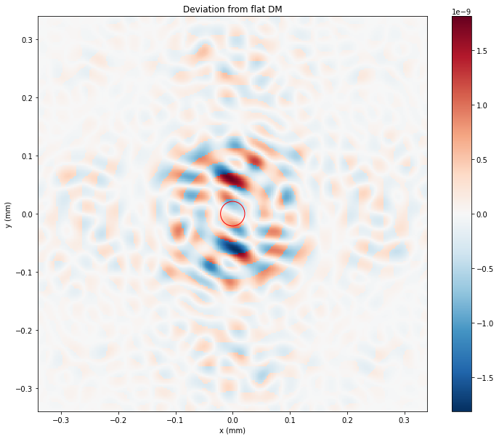
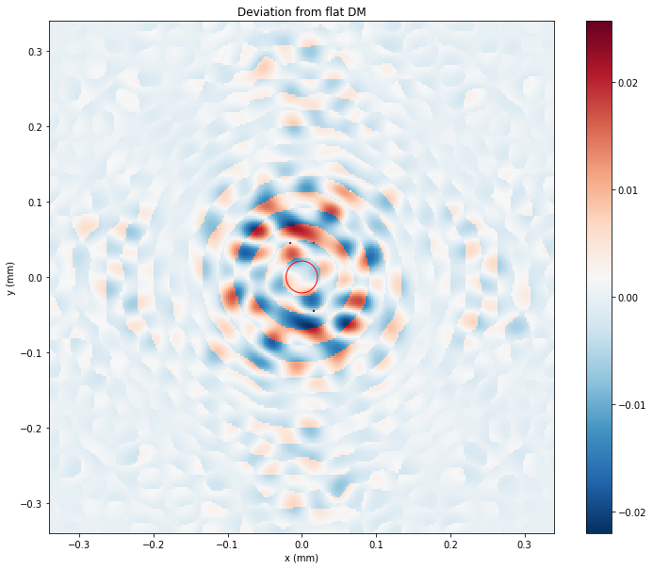
Our setup for testing wavefront sensing is outlined in green in Figure 1. The path of the beam starts on the bottom left in orange, then is later depicted in red and yellow after it is split into two beams with a beamsplitter to produce interference fringes. The region encompassed in magenta simulates the beam interference conducted by the LBTI. Currently, there is a fold mirror in this module of the testbed (right before the beam splitter) to direct the collimated light to the wavefront sensing module which we are currently testing. Without that fold mirror, the beam would get split and the yellow path would pass through the vortex waveplate before coupling into the SMF via the fiber injection unit to demonstrate VFN.
Figure 3: deviation of an example aberrated image from the image of an ideal, flat circular aperture before correction with EFC on the left and after correction on the right. The near-negligible deviations in the right plot (relative to the deviations in the plot on the left) suggest that our implementation of the algorithm performs sufficient correction of an aberrated wavefront.
We consider several focal plane wavefront sensing techniques. The first is electric field conjugation (EFC), which minimizes the aberrated electric field in the image plane by setting the DM actuators to superpose the negative of the electric field (Give’on et al. 2007). Before implementing this algorithm in the lab, we simulated its performance in Python to ensure that we understood the implementation. Figure 3 shows the deviation of an example aberrated image from the image of an ideal, flat circular aperture before correction with EFC on the left and after correction on the right. The near-negligible deviations in the right plot (relative to the deviations in the plot on the left) suggest that our implementation of the algorithm performs sufficient correction of an aberrated wavefront.
Traditional EFC requires an accurate model of the DM influence on the electric field in the image plane as a function of actuator lengths. To circumvent this, we have attempted implementing implicit EFC (iEFC), which is model-independent and instead minimizes difference images since they are simply a linear transformation of the electric field. However, we have been unsuccessful in recovering the injected aberrations in our computational implementation of this algorithm.
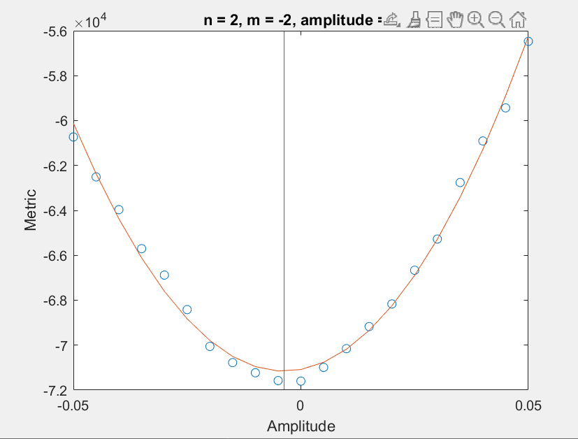
In search of a more straightforward and tractable approach, we have implemented Zernike optimization, in which we perform a grid search through Zernike modes and their corresponding amplitudes and optimize such that the intensity in the core or rings of the resulting Airy disk in the image plane is maximized. We have developed a MATLAB program that solves for the optimized amplitudes for each Zernike mode (see Figure 4). However, we find that the range of Zernike mode amplitudes we search over often corresponds to a local minimum in flux rather than a maximum. This technique requires the aforementioned issue with CCD saturation to be resolved before it will be effective. We are also testing pupil plane wavefront correction using a Shack-Hartmann sensor to measure the aberrations, which then informs the DM actuator positions (traditional closed loop adaptive optics). We wish to use the Thorlabs AOKit software for this purpose but currently face technical issues with getting it to work; we are in communication with Thorlabs and our IT department to resolve this issue. The limitation of using the Shack-Hartmann is that the optical system may introduce aberrations downstream of the pupil plane and thus will not be measured by the Shack-Hartmann.
Figure 2: Example of Zernike optimization for the oblique astigmatism mode amplitude.

Completion of milestones and Visiting Technologist Experience
The first milestone on our Research Training Plan is achieving successful wavefront sensing and correction; completion of this milestone is anticipated for April. Given the delays in tech support from Thorlabs, we have simultaneously begun work on other milestones, such as improving optical aberrations and hardware in the system in hopes of improving VFN performance.
To test the performance of our wavefront sensing techniques, we can measure the Strehl ratio after correction and identify which technique yields a value closest to 1. We can also impose Zernike modes on the DM and check which technique is most sensitive to picking up those modes in the wavefront reconstruction. The goal is to reach an agreement between these methods and adopt the one that optimizes performance and convenience.
We anticipate reducing the wavefront error down to ~12 nm; this is nearly a factor of 2 greater than the idealized λ/100 assumed in Wang and Jurgenson 2020. We expect that our wavefront correction will eliminate the undesirable asymmetric coupling efficiency profile we obtain from the VFN throughput experiment. We also predict obtaining peaks in the throughput profile that match expectations from theory (separations slightly less than ~1 λ/D for both VFN and DAFN). Once we successfully execute this throughput experiment, we will also determine each technology’s sensitivity to low order aberrations by assessing the degree of starlight suppression upon imposing different Zernike modes. We expect the VFN and DAFN to respond to low order aberrations according to theoretical estimates provided in Figures 3 and 10 of Wang and Jurgenson 2020, which generally predict <10⁻⁵ stellar leakage for most Zernike modes.
I have not conducted my Visiting Technologist Experience yet. We anticipate completing it in April/May working with our NASA Research Collaborator, Professor Dimitri Mawet, at Caltech/JPL. The VFN technology was born out of Professor Mawet’s research group and has been successfully deployed on sky for the Keck Planet Imager and Characterizer (KPIC). The goal of our visit would be to gain practical knowledge and experience implementing the VFN technology from the experts who developed it. This process has already begun by establishing lines of communication as we face technical challenges reproducing the results in Echeverri et al. 2019. The visiting technologist experience will also help identify realistic technical goals in accordance with the state-of-the-art established in the field. A visitation experience to NASA-JPL will be extremely beneficial for our comparative studies between the DAFN and VFN technologies to: 1) ensure that the performance evaluation across technologies is self-consistent and 2) share the learnings from both studies that are mutually beneficial due to their overlapping functionality.

Specific technical innovations attributable to your grant work and contribution to the field
As of now, we have not made any specific technical innovations attributable to our work. Once we implement and successfully demonstrate the DAFN, our work will have direct consequences for multi-aperture telescopes, which are becoming increasingly relevant in the era of extremely large telescopes. Wang and Jurgenson 2020 show how the six subapertures of the Giant Magellan Telescope can be configured with different phase offsets to achieve a fiber nuller (FN) analogous to a VFN with a charge = 1 phase ramp. Comparing FN and VFN performance suggests that there is a trade-off between system complexity and full coverage at a given separation. Developing our DAFN testbed and conducting our comparative studies with the VFN is the first step towards demonstrating these differences between the two technologies in practice.
The DAFN concept is also a direct extension of the LBTI, the interferometer on the Large Binocular Telescope (to which we have institutional access). The DAFN would require feeding the light from LBTI into a near-infrared spectrograph on the backend with a single mode fiber. As a result, the DAFN may be a natural evolution for the upcoming instrument iLocater. iLocater is a fiber-fed, high-resolution echelle spectrograph for the Large Binocular Telescope operating in the near-infrared for sub-meter-per-second radial velocity precision. It is optimized for detection of low-mass planets using the Doppler technique. Development of the instrument has transitioned from University of Notre Dame to our Imaging Sciences Lab in the astronomy department at OSU due to iLocater’s co-PI joining within the past 6 months. Consequently, we have the expertise in-house to design the DAFN concept specifically for compatibility with iLocater in mind.

Significant events such as qualifying exams or teaching experiences.
My remaining academic requirements are a thesis proposal presentation and the dissertation defense. I intend to complete the thesis proposal by the end of the summer.
At the start of the academic year, I was one of the instructors for a two-week early arrival program for incoming freshman interested in physics and astronomy called URSA. Through this program, we aim to introduce the students to academic research in the field by providing them with various opportunities to: 1) learn new science concepts and apply them in the context of real academic research, 2) recognize and reinforce their scientific accomplishments to encourage retention in the field, 3) consciously evolve their cognitive skills, 4) educate them about the social underpinnings of academia, and 5) develop a sense of place within their cohort community. I developed science lessons about exoplanet detection and characterization techniques as well as concepts in social cognitive career theory and group study techniques to equip students with the tools to develop a sense of belonging. During the second week of the program, I guided the students through a group mini research project. I also designed an instrumentation lesson and lab for the URSA program that included a hands-on activity teaching basic optics for telescope design using a ray box and optics kit as well as an activity using Arduinos to build a photometer to simulate exoplanet transits.
Unanticipated opportunities, surprises, or unusual developments
The biggest change in our plan for this year has been dropping our attempts to implement EFC for wavefront reconstruction despite investing significant time simulating it computationally. We have found it challenging to implement EFC in practice because it requires a robust model of the physical system’s response to phase perturbations. It may be a needlessly complicated endeavor given that we have a Shack-Hartmann sensor that can serve the same purpose instead. Furthermore, there are existing software for closed loop adaptive optics that we can use instead of reinventing the wheel.
Another challenge has been getting timely technical support from Thorlabs on seemingly simple issues. We have been going back and forth with their technical support team since December trying to diagnose an issue with their AOKit software. We also have not been able to resolve the issue of reading in 16-bit images from a Thorlabs CCD programmatically for over a month. These delays led us to work towards other milestones on our Research Training Plan, specifically the VFN demonstration, while we wait for solutions to our technical difficulties.
We also chose to go back to the VFN experiment upon the recommendation of our new instrument scientist. He has offered practical suggestions to ensure that the asymmetric throughput curve we obtained in Figure 2 is not due to shear introduced by vortex mask itself (which would not be resolved by implementing wavefront correction upstream of the vortex). Upon his suggestion, we are also considering upgrading our hardware for the output fiber mount and the vortex mask. Given that our pupil is 4 mm, we require the resolution in positioning the vortex down to within ~20 microns (Ruane et al. 2019); as such we will need to upgrade the drives on the vortex mask’s translation mount to differential drives with finer resolution. Likewise, we may need to mount our fiber on a piezo-controlled positioner. This will allow us to achieve finer precision in the fiber’s position (especially since the mode field diameter of the fiber is a mere 4.5 microns) and automate the process of aligning the beam into the output fiber, searching for the null when the vortex mask is installed, and conducting the throughput profile experiment.
Summary of Plans for the Coming Award Year and Updated Milestone Schedule

Plans for the coming grant year that would be supported by grant continuation funding
Our goal is that after my visiting technologist experience, we will successfully demonstrate VFN by the end of the summer. The next step for the coming grant year will be implementing the DAFN design into the testbed. The DAFN combines nulling interferometry with a single mode fiber connected to a high-resolution spectrograph to cancel out host star light and extract a planetary signal. The host star’s light is suppressed by interference fringes and filtered out by the single mode fiber. In principle, the planet’s signal can be further distinguished from the host star’s in velocity space with high-resolution spectroscopy. As previously mentioned, this instrument concept is a direct extension of the LBTI framework with single-mode fiber and high-resolution spectrograph on the backend.
To complete our setup of the DAFN, we need to install a corner cube reflector and adjust the path length until the on-axis destructive fringe intensity is minimized. The fringes will be measured with a CCD and their visibility will be optimized before they are aligned into the single mode fiber. We will repeat the throughput profile experiment that we conducted for the VFN and test the sensitivity of the DAFN’s starlight suppression to low order aberrations. We will compile the results of our comparative studies in a publication.
Once the VFN and DAFN are demonstrated in monochromatic light, we will move on to broadband light and optimize the system with fringe-tracking and beam-shaping before we inject an infrared source and repeat these experiments. These tasks will likely extend beyond the coming grant year.

Updated milestones for both your research and academic progress, planned graduation date, and any interim academic events
Our updated milestones are as follows. I aim to conduct my Visiting Technologist Experience in April/May. This experience will inform our efforts towards wavefront reconstruction and demonstrating VFN performance. We aim to successfully reproduce the results of Echeverri et al. 2019 by the end of the summer of 2023. During this time, I will also aim to complete my thesis proposal presentation. We will then work on integrating the DAFN design into the testbed and demonstrate DAFN performance by the end of 2023. We will write up our findings for publication, then work on optimizing the system in broadband light all the way through summer of 2024. Extending the testbed to the infrared will likely go into the 2024-2025 academic year until my graduation in June 2025.

Plans for a Visiting Technologist Experience at a NASA Center or not-for-profit Laboratory during the continuation year
We do not have any definite plans for the Visiting Technologist Experience during the continuation year. However, NASA AMES may be a good option to learn from the developers of the hybrid PIAA (phase induced amplitude apodization) vortex coronagraph.

Summary of Changes
Changes since your last grant continuation to the title technical objectives
At present, we do not have any changes to our technical objectives.

Changes to technical approach
The major change to our technical approach is that we are no longer attempting to implement EFC in the testbed. It is possible that the asymmetric throughput curves in our VFN experiment (Figure 2) may be from tip-tilt on vortex waveplate introducing shear. This aberration will not be resolved by wavefront correction because the wavefront sensing will need to happen upstream of the VFN where we know how to optimize the wavefront in phase (the vortex applies a transformation in phase that cannot be addressed with traditional wavefront reconstruction techniques). We will first attempt upgrading our hardware for greater alignment precision. If wavefront correction is still needed, we will attempt pupil plane Shack-Hartmann closed-loop adaptive optics after we have tested it against Zernike optimization in focal plane.
Another possible change to our technical approach that we are considering is inserting a dielectric phase plate to tune the interference between the two beams instead of changing the path length of one beam with a corner cube reflector. We will postpone making this decision until we have made a preliminary attempt at implementing the DAFN setup in our testbed.

Expected outcomes
We expect that the changes to our technical approach will have a more direct impact on reproducing the VFN experiment on a reasonable timescale. We will prioritize getting the expected results before optimizing them with techniques like wavefront correction to achieve a deep null and reduce sensitivity to aberrations. We expect the VFN and DAFN to perform according to theoretical estimates provided in Figures 8 and 10 of Wang and Jurgenson 2020.

Grades
Not applicable.

